School Vision

‘Equipping our children with the knowledge and skills to navigate life successfully.’

There has been a conscious decision made to have school Aims. These provide greater explanation to our core purpose and the tangible link between achieving our Vision and the meaningful connection between our Values, ‘Skills for Learning’, curriculum, positive behaviour management strategies and life in our school. If we are successful with teaching the ‘Skills for Learning’; if the school Values are instilled; if children can self-regulate their behaviour and we achieve our school Aims then we will achieve this Vision.

Aims

We aim …

- For our children to be happy, have fun and enjoy school.

- To motivate and inspire children to enjoy learning and face all challenges with confidence and maturity.

- To provide a school environment where children and adults feel safe and secure.

- To provide children with curriculum experiences that enables them to make appropriate decisions and keep themselves safe.

- To deliver a meaningful (contextual) and well planned curriculum which offers enrichment and challenge and is led by knowledgeable subject leaders.

- To provide the highest of expectations for teaching, learning and outcomes.

- To provide opportunities for all children to participate in outdoor learning including a physically active and healthy curriculum.

- For our children to establish positive mindsets within a supportive environment where failure leads to success and new learning.

- To provide strategies for children to independently overcome various challenges by teaching our ‘Skills for Learning’ in order to be successful now and in their future lives.
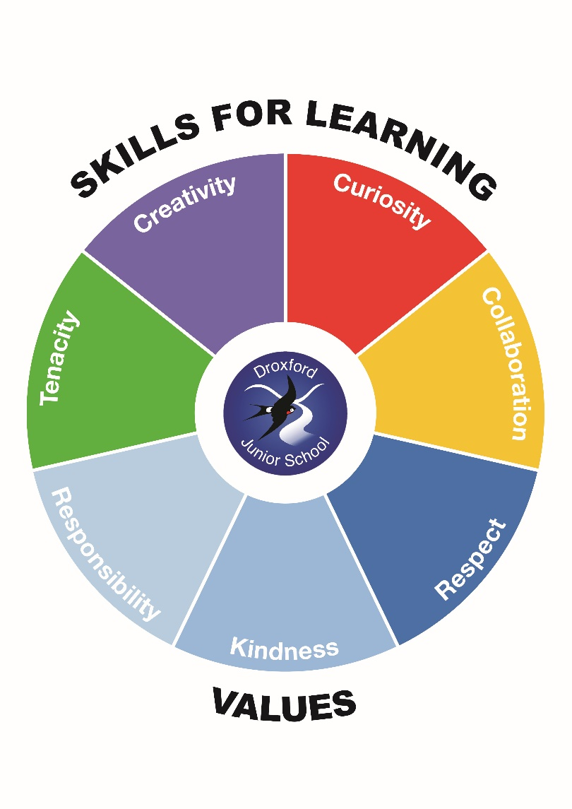
Children will be taught and encouraged to use their ‘Skills for Learning’ every day. To be Tenacious: is being resilient; to persevere; showing grit and determination and being positive in times of adversity. Tenacity helps with problem solving and overcoming challenges – physical and mental. Tenacious people share their tenacious spirit. Being Creative: helps to solve problems and ensure we know there is more than one way to do this; creativity is personal and individual; is literal (linked to the arts) and can be about invention and enterprise. Creative people are resourceful and can share this resourcefulness. Being Curious is important when we are inquisitive and test new theories; is about asking questions to find new learning; is about discovery; being open minded and positive and being courageous – understanding new learning comes from mistakes. Curiosity is about being proactive not passive! Finally Collaboration is about teamwork and communication skills; working with a variety of teams and individuals in and out of school including parents, governors and members of the wider community. Collaboration can happen in school or out. Collaboration takes place on school trips and all these ‘Skills for Learning’ will be used on residentials!

We feel that these positive characteristics and habits of mind are not only important to display now but also in secondary school and vital in later lives and careers.

Home School Agreement

Child’s Name:…………………………………………

The Parents/Carers

I/We will try to:
- Ensure my child attends school regularly, on time and properly equipped.
- Inform the school about concerns or issues that may affect my child’s learning.
- Support the school Values of Droxford Junior School.
- Support my child with home learning and specific homework tasks.
- Attend parent meetings and discussions about my child’s progress.
- Be involved with my child’s life at school.

The Child

I will try to:
- Attend school regularly and on time.
- Be well organised and have the equipment I need each day.
- Follow the Droxford Junior school Values.
- Work hard at school and complete homework so that I make good progress.

The School

We will try to:
- Provide a caring and safe learning environment.
- Promote the Droxford Junior school Values and achieve high standards.
- Support and challenge your child to make good progress and achieve their potential.
- Offer a relevant curriculum for learning that motivates your child to develop key learning skills – Tenacity, Collaboration, Curiosity and Creativity.
- Promote healthy lifestyles.
- Develop positive working relationships and open communication.
- Keep parents/carers informed about their child’s progress and concerns.

Signed: Headteacher Date:

Signed: Child Date:

Signed: Parent/Carer Date:

